For more information about our Ministry or, for speaking engagements, please call (253) 324-7902
Web site: www.greaterfaithoutreach.com
Greater Faith Outreach Ministries
Elizabeth Hamilton (Pastor, Evangelist & Teacher of the Word of God)
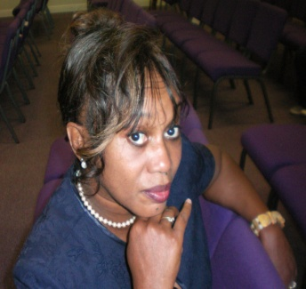
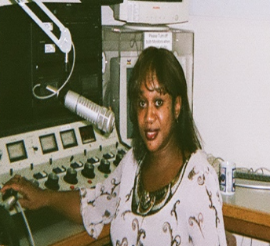

I was born in a small Town in the Mid West. I left there at an early age, and moved to the Bay Area, Oakland California to live with my Sister, we lived right above the Liquor Stores, the family owned, in West Oakland, where it was pretty hard core, even the Police had a fear of entering, just to give you a little idea of where I lived, and by living there and not knowing Christ you developed a certain hardness which builds up pretty quick, through drugs, alcohol, and the people you hang out with, a total turnaround from the way I was raised, I was pull in to things that only the Lord could have pulled me out of. The Lord moved me and my children here to Washington, around 30 years ago, but that did not stop the Hit that the enemy had on my life, there were people that found out I was here in Washington, and they came after me (my soul). And again the Enemy thought he had me, BUT GOD!! The Lord delivered me, and reconciled me back to Himself, a few years of just putting a seatbelt on my mind and studying, applying the Word and staying in His presents Moment, my Moment, He set me up for Ministry (It’s been about 25 years now) !! I was placed at Matsusaka where the Ministry grew rapidly. Called by God and officially Ordained By Bishop Benjamin in Dallas Texas in 1990 and again ordained Through Everlasting Life Celebration Church, By“Pastors, Brad & Rebecca Blaisdell.”I was The Pastor of Holy Faith Outreach Church on East 72nd St. for a few years. Now God has moved me outside the Walls into the deep! Greater Faith Outreach Ministry was established by God, in 1999. He has given me a Tremendous Vision, and I am yet to walk in the fullness of it!! Until the return of Christ, it is our duty and privilege to seek the fulfillment of Christ's Great Commission and to minister in His Name to a needy world. I believe we are to be instruments
of Jesus Christ as the Holy Spirit ministers through us redemption
And reconciliation to the world. (Matthew 25:31-46; 28:18-20)
To be His hands, His feet, and His light extended.
How we love God and love others is evidence that we are Children of God.
And last but not least how we live our lives before Him is what really counts.
God’s deepest desire is that we show our love for Him by obeying His Word
and by being wise managers of all His resources.
God has launched Greater Faith Outreach Into.
*Prison Ministry
*Corporate Intercessory Prayer
*Spiritual Tools, The loving Arms World Wide
* Radio Station “KLAY 1180 AM” (every Sunday 5:30 pm)
*World Wide Bible Study > Every Tuesday nights. At 6:00 pm (Pacific Time).

